**Practical No 1**

**Aim : Creation of Dimensions and Fact tables.**

**Solution :**

**Open Application -> Microsoft SQL Server 2008 R2 -> SQL Server Management Studio**

1. **Select Connect Tab -> Database Engine -> Select Server Name(local)**
2. **Right Click the Database -> New Database**
3. **Types “SalesInformation” as the database name, click on OK to close the dialog box and to create the databse.**

**Create a Database Diagrams**

**Expand the “SalesInformation” database folder.**

1. **Click on Database Diagrams to expand it**

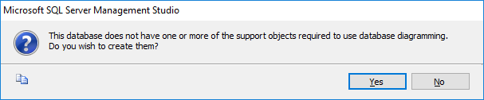

**On click of it, above Dialog box appears, click on Yes to close it.**

1. **Right Click on Database Diagrams -> New Database Diagrams**
2. **Create fact and Dimension Tables. (Right click on surface, choose New Table to add tables on Database Diagrams.)** 